

Robotic HPB Surgery
Hands on
Cadaveric Dissection Course

October 7-8, 2025
NEWCASTLE SURGICAL TRAINING CENTRE

Newcastle Surgical Training Centre

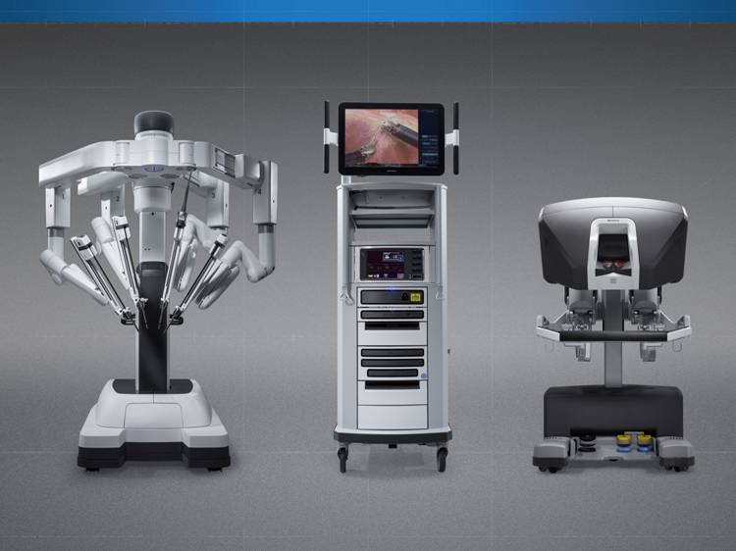
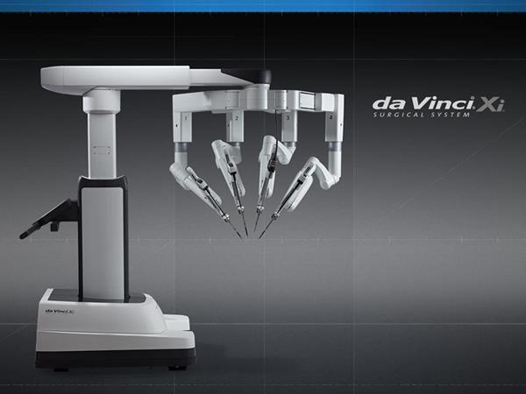



Newcastle Surgical Training Centre
Freeman Hospital, Newcastle upon Tyne

THE VERY LATEST TECHNOLOGIES FOR MINIMALLY INVASIVE SURGERY FOR ROBOTIC TRAINING

G
The HPB Robotic / Minimally Invasive Surgery Hands on Cadaver Dissection Course

July 1-2 2024

SPECIAL FEATURES OF THE COURSE

The 3rd UK
DAY ONE Pancreas

08:00 – 08:30 | Registration and Coffee
08:30 – 08:40 | Introduction and aims of the course | SEMINAR ROOM | Prof Steve White
08:40 – 09:10 | Learning curve in Robotic pancreatic resection | SEMINAR ROOM | Sanjay Pandanaboyana
09:10- 09:40 | Da Vinci System/technology/instrumentation | SEMINAR ROOM | Sam Colbear
10.00 | Live Link- Robotic Distal Pancreatectomy
10:00 – 10:30  Chair: Fabio Ausania | COFFEE BREAK
10:30 – 11:00 | What could possibly go wrong with Robotic systems | SEMINAR ROOM | Amy Bradburn
11:00 – 11:45 | Robotic Distal Pancreatectomy +/- Splenectomy | SEMINAR ROOM | Steve White
11:45 – 12:15 | Robotic Pancreatoduodenectomy | SEMINAR ROOM | Zahir Soonawalla
12:15 – 13:00 | LUNCH BREAK | SEMINAR ROOM
Chair Steve white

13:00-14:00 | Robotic pancreatoduodenectomy: Trials and Tribulations |  | Prof Kalayarasan Raja  JIPMER, India
14:00– 15:30 | LIVE LINK | SEMINAR ROOM
15:30 – 16:00  Chair: John Moir | COFFEE BREAK
16:00 | Robotic pancreatic surgery : Current evidence and future perspectives | SEMINAR ROOM | Mr Jeremy French
16:15 – 16:30 | Close of Day One | SEMINAR ROOM

Conference and Hands on Dissection Course

Day Two Liver
 | Chair Prof Steve White
09:15 | Introduction – Sanjay Pandanaboyana
09:15 – 09:45 | HCC: Resection versus Transplant |  | Derek Manas
09:45 – 10:15 | Robotic liver resection-parenchymal transection methods |  | Mr Al-Leswas
10:15 – 10:30 | COFFEE BREAK
Live link – Robotic Liver resection
Chair: Prof Derek Manas
10:30 – 11:00 | Benign liver lesions and current guidance | SEMINAR ROOM | Rohan Thakkar
11:00 – 12:00 | Robotic Biliary Surgery | SEMINAR ROOM | Fabio Ausania
12:00 – 13.45 | LUNCH BREAK but in live link  Chair: Rohan Thakkar
13:45 – 15:00 | Robotic fenestration of Liver cysts |  | Fabio Ausania
15:00 – 15.15 | Evaluation, Summary & Close | SEMINAR ROOM

DAY 1 GROUP TIMETABLE
8:00 – 10:00  GROUP 1 | FACULTY: Zaheer Soonawalla  DELEGATES: | Cholecystectomy  Distal Pancreatectomy/Splenectomy
11:00 – 1200  GROUP 2 | FACULTY: Jeremy French  DELEGATES: | Left lateral liver resection  Suturing/Metastectomy Rt Lobe  Pringle’s maneouvre
12:00 – 14:00  GROUP 3 | FACULTY: Steve White  DELEGATES: | Cholecystectomy  Distal Pancreatectomy/Splenectomy
14.00 - 16:00  GROUP 4 | FACULTY : Fabio Ausania  DELEGATES: | Left lateral liver resection  Suturing/ Metastectomy Rt Lobe  Pringle’s maneouvre

DAY 2 GROUP TIMETABLE
07:45 – 9:45  GROUP 4 | FACULTY: Jeremy French  DELEGATES: | Cholecystectomy  Distal Pancreatectomy/Splenectomy
1000 – 12.00  GROUP 3 | FACULTY: Fabio Ausania  DELEGATES: | Left lateral liver resection  Suturing/ Metastectomy Rt Lobe  Pringle’s maneouvre
12:00 –13.00  GROUP 2 | FACULTY: Zahir Soonawalla  DELEGATES: | Cholecystectomy  Distal Pancreatectomy/Splenectomy
13.00 – 15.00  GROUP 1 | FACULTY: Sanjay Pandanaboyana  DELEGATES: | Left lateral liver resection  Suturing/ Metastectomy Rt LobePringle’s maneouvre

